**Microfluidics Lab** Regis Zhao

INTRODUCTION

Fluid mechanics is a ubiquitous branch of physics, finding applications in many technological applications our world regularly depend on. Microfluidics in particular has numerous biological applications that rely on our understanding of fluids on the micro-scale. As with any field of science, there are a number of core concepts and principles in fluid mechanics. We will focus on two fundamental equations: Bernoulli’s equation and the continuity equation. A common form of Bernoulli’s equation is:

|  |  |  |
| --- | --- | --- |
|  | $$\frac{P}{ρ}+\frac{v^{2}}{2}+gz=C$$ | (1) |

where $C$ is a constant. It allows us to understand the behaviour of fluid flow with respect to pressure, velocity, and elevation. Although we focus on its application in describing fluid flow, the continuity equation is a very broadly applicable equation that can describe many physical phenomena. In fluid mechanics, the equation often takes the form:

|  |  |  |
| --- | --- | --- |
|  | $$A_{1}v_{1}=A_{2}v_{2}$$ | (2) |

where $A$ and $v$ represent cross-sectional area and flow velocity, and the subscripts represent different regions of flow. In this lab, the objective is to examine fluid flow on the micro-scale and analyze how well the continuity and Bernoulli’s equations describe fluid behaviour at that scale. Under a microscope, we view a fluorosphere suspension (kept in a syringe) flow through differently-shaped channels in a microfluidics chip and use software (LAS) to capture images and gather data on the fluid’s behaviour.

EXPERIMENTAL PROCEDURE AND RESULTS

The overall procedure from the given lab manual was followed. The section regarding the hemacytometer was omitted from the experiment since the software used to capture images provided a scale on the images.

To determine the fluid velocity: velocity is equivalent to the distance travelled by a fluorescent bead in a certain amount of time divided by that amount of time. By adjusting the exposure time, the fluorescent beads would produce streaks in the captured images. Viewing the images on my laptop, the length of these streaks were measured using a ruler, then multiplied by a scaling factor (determined also by measuring the given scale using a ruler) to determine the actual distance travelled by the beads. The general formula for the velocity was then:

|  |  |  |
| --- | --- | --- |
|  | $$v=\frac{measured streak length×\frac{actual length of scale}{measured length of scale}}{exposure time}$$ | (3) |

ERROR ANALYSIS

Only multiplication and division operators are used on the collected data to calculate the fluid’s velocity. Therefore, to determine the error in the computed velocities, we use the error propagation formula for the particular case of functions that only involve multiplication and division:

|  |  |  |
| --- | --- | --- |
|  | $$σ_{f}=f\sqrt{{\left(\frac{σ_{a}}{a}\right)}^{2}+{\left(\frac{σ_{b}}{b}\right)}^{2}+…}$$ | (4) |

where $σ_{x}$ is the uncertainty in variable $x$, and $f$, the computed result, is a function of variables $a$ and $b$.

An example of the calculation of error in velocity is shown below.

Measured streak length = 0.3 cm ± 0.05 cm (instrumental uncertainty)

Measured length of scale = 4.2 cm ± 0.05 cm (instrumental uncertainty)

Actual length of scale = 100 µm

Exposure time = 0.4326 s ± 0.00005 s (instrumental uncertainty)

Using equation (3):

$$v=\frac{0.3×\left(\frac{100}{4.2}\right)}{0.4326}=16.5 μm/s$$

Using equation (4):

$$σ_{v}=16.511\sqrt{{\left(\frac{0.05}{0.3}\right)}^{2}+{\left(\frac{0.05}{4.2}\right)}^{2}+{\left(\frac{0.00005}{0.4326}\right)}^{2}}=2.7 μm/s$$

$$∴v=16.5 μm/s±2.7 μm/s$$

Beyond the reading and instrumental uncertainties of the ruler used and the limitations of the software when recording the exposure time, other sources of error include imperfections in the channels and sidewalls, as well as the resolution of my laptop screen. Imperfections in the channels were most likely to significantly skew results since in many cases, their affect on the fluid flow was visible in the captured images. Contrarily, error arising from my laptop screen’s resolution is likely insignificant considering how small the pixels are compared to the instrumental uncertainties of the ruler – any error produced by insufficient resolution is most likely covered by the ruler’s instrumental uncertainty.

DISCUSSION

Channel Imperfections

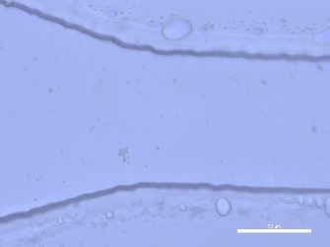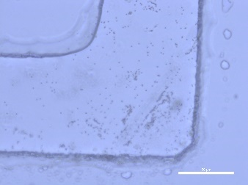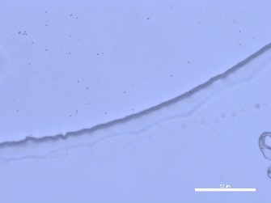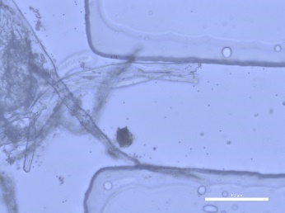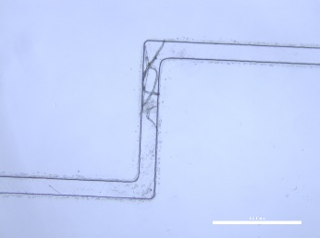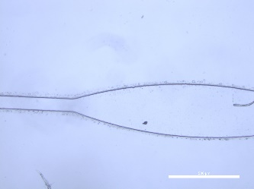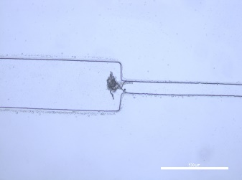Initially, viewing the channels with 5x objective magnification (Figure 1), we notice some sidewall imperfections as well as imperfections in the channels themselves. Zooming in to 40x magnification (Figure 2), we see that although the sidewalls are relatively smooth, there are noticeable imperfections that occur as small divots/bumps into/out of the sidewall. Most of the imperfections are roughly 1 µm to 10 µm long and 1 µm to 4 µm in depth. These sidewall imperfections may cause slight turbulence near the sidewalls as it disrupts the streamline nature of laminar flow.

*Figure 1. The four uniquely shaped channels under 5x objective magnification.*

*Figure 2. The four uniquely shaped channels under 40x objective magnification. There are many noticeable imperfections in both the channel and sidewall.*

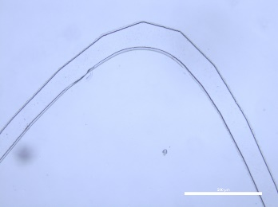

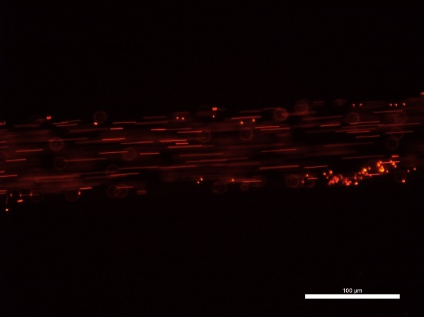Straight Channels

*Figure 4. Flow velocity profile of the straight channel in Figure 3.*

*Figure 3. Straight portion of one of the channels. Laminar flow observed.*

The fluorosphere suspension displayed laminar flow through the straight portions of the channels, shown in Figure 3. Calculating the velocity of the fluorescent beads at varying heights along the width of the channel, we can plot height in the channel against the fluid’s velocity, generating a velocity profile, shown in Figure 4. As seen from the graph, the fluid’s maximum velocity occurs near the centre of the tube, while the lowest velocities occur at the edges of the channel near the sidewalls. From this, we can deduce that the largest velocity difference is between the centre and the sidewalls of the channel.

We were able to manipulate the velocity of the fluid by adjusting the position of the syringe relative to the microchip. The higher we positioned the syringe, the higher the flow velocity; the lower the syringe was, the lower the velocity. This behaviour can be attributed to the fact that, by raising the syringe, we are increasing the gravity head and therefore increasing the overall pressure of the system. Referring back to Bernoulli’s equation (Equation 1), this in turn increases the dynamic pressure of the system (middle term of the left side of Bernoulli’s equation), which therefore causes the increase in flow velocity. By increasing the amount of fluid, we are essentially doing the same thing (increasing the gravity head) and therefore it has the same effect on the flow velocity.

Channels of Different Size

Using the continuity equation discussed earlier (Equation 2), we can calculate expected values for the velocity based on changes in the channel’s width when given an initial channel width and flow velocity. We assume that the channel cross section is circular and the width seen in the images are equal to the channel’s diameter. Furthermore, since the bead streak lines are longer and clearer to see near the centre of the channel, we consistently measure and calculate for the flow velocities at the centre of the channel. Based on the continuity equation, we expect there to be an inverse relationship between the channel width and the velocity. This relationship is reflected in both the theoretical and measured values shown in Table 1 below, though the measured and theoretical values are not similar at all. This is likely due to the channel imperfections that can be visibly seen affecting the fluid flow in the captured images below in Figure 5 and 6.

Table 1.Measured and theoretical values of flow velocity for channels of different width.

|  |  |  |  |  |
| --- | --- | --- | --- | --- |
| Type of width change |  | Flow Velocity (µm/s) at different channel widths | | |
| Channel width | Before width change (95 µm) | During width change (190 µm) | After width change (375 µm) |
| Gradual | Measured | 440.4 ± 14.7 | 247.7 ± 14.1 | 165.1 ± 13.9 |
| Theoretical | N/A | 110.1 ± 4.4 | 28.4 ± 1.2 |
| Abrupt | Measured | 694.7 ± 32.7 | N/A | 189.5 ± 31.7 |
| Theoretical | N/A | N/A | 44.8 ± 2.4 |

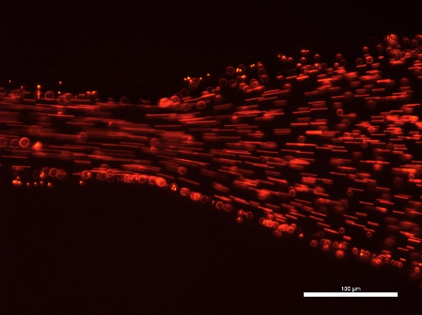

*Figure 6. Abrupt width transition channel. Some turbulent flow observed at the edges of the channel.*

*Figure 5. Gradual width transition channel. Predominantly laminar flow.*

Comparing the images taken of the gradual width transition against the abrupt transition, we can see that in the gradual width transition channel, the flow remains laminar while the flow in the abrupt transition channel seems to become turbulent near the edges after the channel widens. While this may be due to the significant imperfection in the abrupt transition channel seen in Figure 6, it is worth noting as the turbulent flow could be attributed to the sudden change in width. Adjustments to the gravity head cause the same results as discussed in the previous section; increasing the amount of liquid raises the head, therefore causing the flow velocity to increase.

Bends in Channels

The general trend when measuring the flow velocity near bends in the channel was that the flow velocity was lower before and after the bend, while it was significantly higher during the bend. Specifically comparing the velocities before and after the bend, there did not seem to be a trend as the after bend velocity was higher than that of the before bend for the curve, while the inverse was true for the sharp turn. Measured flow velocities are shown in the table below.

Table 2. Measure values of flow velocity at different points of channel bends.

|  |  |  |  |
| --- | --- | --- | --- |
| Type of bend | Flow Velocity (µm/s) at different points of bend | | |
| Before bend | During bend | After bend |
| Curve | 82.2 ± 10.3 | 308.1 ± 10.9 | 143.8 ± 10.4 |
| Sharp turn | 286.2 ± 28.8 | 515.1 ± 29.3 | 228.9 ± 28.7 |

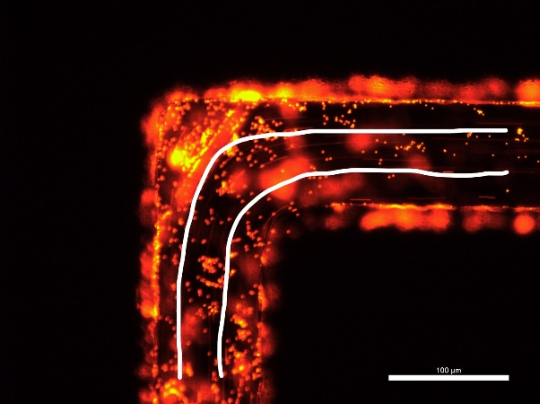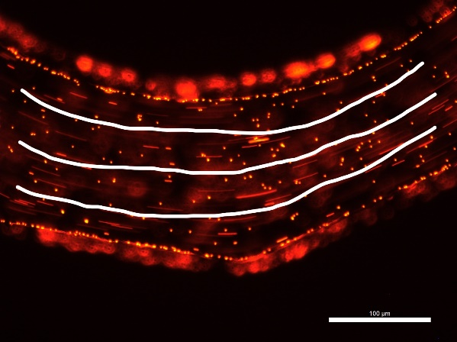

*Figure 7. Curved bend channel. Laminar flow exhibited.*

*Figure 8. Sharp turn bend channel. Laminar flow exhibited.*

Observing the images captured above in Figures 7 and 8, the flow in both types of bends seems to exhibit laminar behaviour as all the streak lines seem to be parallel with each other. Comparing the two types of bends to each other, there does not seem to be any significant discrepancies in the fluid’s behaviour. In both cases, they take smooth, curved paths around the bend, as drawn in the figures above.

CONCLUSION

This lab allowed us to demonstrate the functionality of Bernoulli’s equation and the continuity equation. Although the measured and theoretical results did not match, likely due to channel imperfections, the inverse relationship between cross-sectional area and flow velocity described by the continuity equation was displayed by examining the flow velocities through changing channel widths. The relationship between the gravity head and dynamic pressure described by Bernoulli’s equation was demonstrated by observing increases in flow velocity when increasing the amount of fluid or raising the syringe’s position. This experiment provides insight into and serves as a physical demonstration of two critical concepts in the field of fluid mechanics.

REFERENCES

[1] AER210 Introduction to Microfluidics – Lab Manual